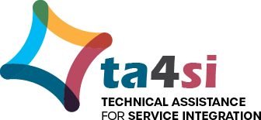
Social Media Toolkit for
BIDLS-Funded Agencies
Summer 2020

Agencies funded by the Bureau of Infectious Disease and Laboratory Sciences (BIDLS) continue to meet client needs while keeping themselves and their clients safe during the ongoing nationwide COVID-19 public health emergency. The following social media toolkit includes tips for success, sample messages, and images that will support digital communication of important information about the availability of and changes to infectious disease services and primary care. Messages can be modified to suit your needs.

Tips for Success
The following best practices can support your agency’s posting to your social media platforms. We also invite you to review our webinar recording and slide deck (https://ta4si.jsi.com/category/social-media/) on best practices for social media.

If you’re just getting started with social media, remember to fill out the Massachusetts Department of Public Health Social Media Recruitment Standard of Service.

- Goals should drive strategy: Are your social media activities supporting your communication/outreach goals? The goals your team sets for outreach should drive your strategy and should come first. We suggest sitting down with your team and outlining your goals, then determining which social media strategies will help you get there. Learn more about goal setting in the POST Framework section of our webinar (link above).
- Telephone vs. megaphone: Social media is social, but sometimes it can feel like a one-way conversation. When writing for social media, think about sparking a conversation: how can you get your audience to engage with you? Can you ask questions or ask for feedback? Additionally, we recommend setting aside some time each week to engage with comments.
- Include a call to action: When you write content for social media, ask yourself what you’d like your audience to do after reading the post. Would you like them to visit your website or make an appointment for testing? That’s your call to action! We recommend using a call to action in the majority of your posts.
- Be visual: More than ever, visuals matter on social media. Posts with visuals, including graphics or videos, have higher engagement than posts with text alone. There are many great, free tools for creating graphics, like Canva, that can help you get visual.
- Measure what matters: Use metrics, like views, reach, likes, and comments, to measure your outreach efforts and guide future content creation. You can use tools like Hootsuite or Sprout Social to track your metrics, but many social media platforms have their own metric tracking tools. We recommend tracking your metrics on a routine basis, like weekly or monthly.

Sample Messages

Testing Services
- Our offices may be closed for services right now, but we can help you reschedule preventive visits, like testing. Let’s all do our part to stay safe.
- We’re still offering [HIV/STI/Hepatitis C] testing. Give us a call to find out how you can get a test!
- The world is changing, and so have our HIV testing services. [insert services/hours, e.g. We’re testing from 1pm until 8pm, We’re offering at-home testing, etc.]

Case Management
- Have you talked to your case manager lately? Give us a call and talk about how we can be of service to you while physical distancing!
- Your [Case Manager/PrEP Navigator/Linkage Coordinator] is still available if you need them. Reach out to see what services we’re offering.
- If you’re physical distancing to protect your health right now, our team is still here for you! Give us a call to find out more about remote visits.

Prescription Management
- Do you need to refill your prescription? You can call our office to request a refill today.
- Many pharmacies are offering home deliveries. You can check with your pharmacy to see if they’re offering this service.
- We’re here for you! You can still receive support and treatment for HIV, HCV, and STIs. Give us a call to discuss curbside pickup for medications and other treatment services.
- Do you take medications? It’s a good idea to have at least a 30-day supply of your medications in hand. If you live in MA, you may be able to get 60- to 90-day supplies of your medication. You can call us to learn more.

Telehealth Services
- Taking extra precautions because of COVID is a way to stay safe and healthy. We get it! We’re now offering services via telehealth that you can take part in from home. Find out by [calling, going to site, etc.]
- Our doors may be closed, but many of our services are still available via telehealth visits! Make a telehealth appointment by [insert agency instructions]
- Our telehealth services are available to you from the comfort of your own home! Schedule a virtual appointment with us today.
- Our clinic is taking extra precautions to ensure the safety of our clients and staff. If you feel sick, please call our office to schedule a telehealth visit.
Mental Health Support
- It can be easy to feel lonely and disconnected right now. Connecting with friends over text, direct message, or video is a good way to fight boredom, increase connection, and support your mental health.
- Physical distancing can weigh heavily on your mental health. We have services available that you can use from your phone/computer to speak with someone. Call us to see what’s available for you!
- It’s normal to feel anxious or nervous right now. Visit @CDCgov for tips on supporting your mental health during this time: https://bit.ly/2X2uPYv

The images below are available to download in a ZIP file on our website (https://ta4si.jsi.com/social-media-toolkit-images/). These images can be used on Instagram, Facebook, or Twitter.

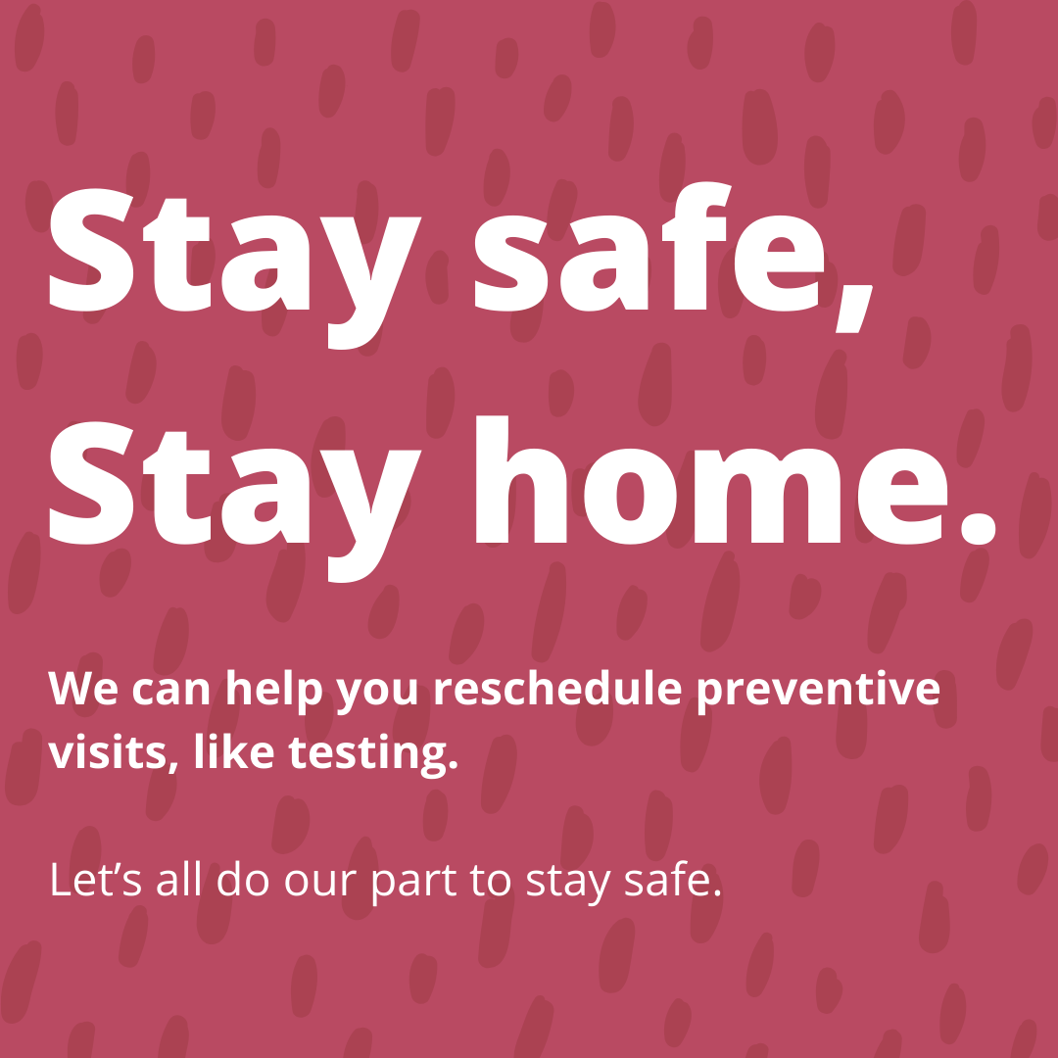
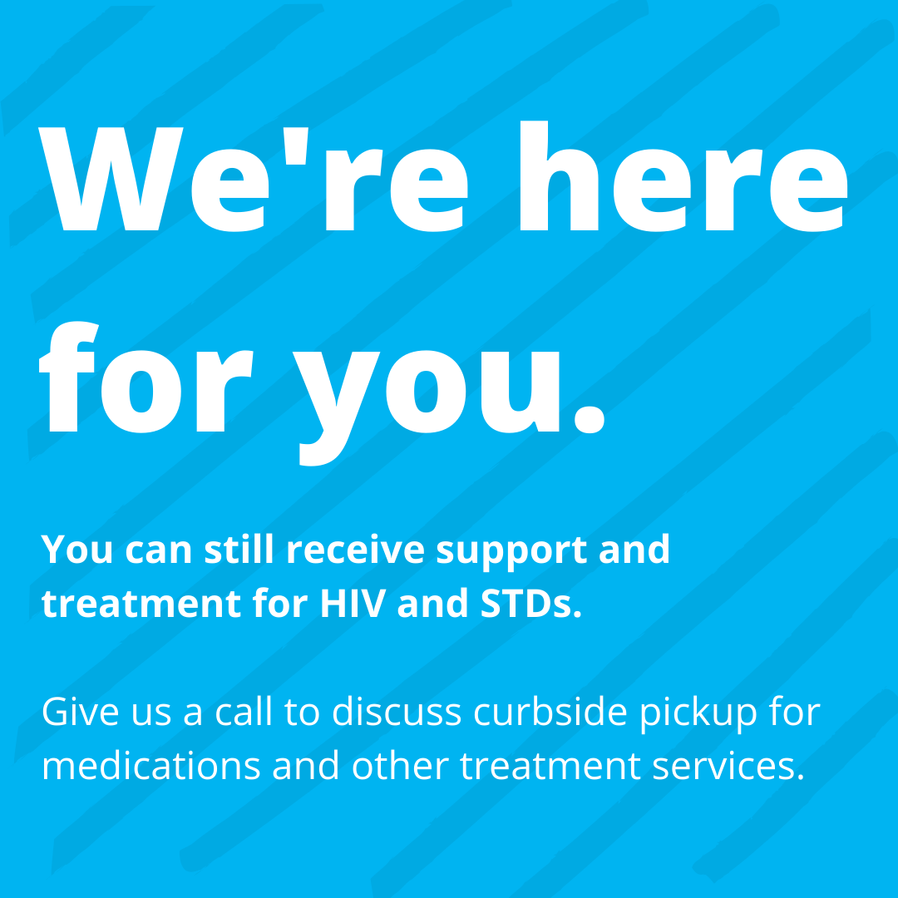
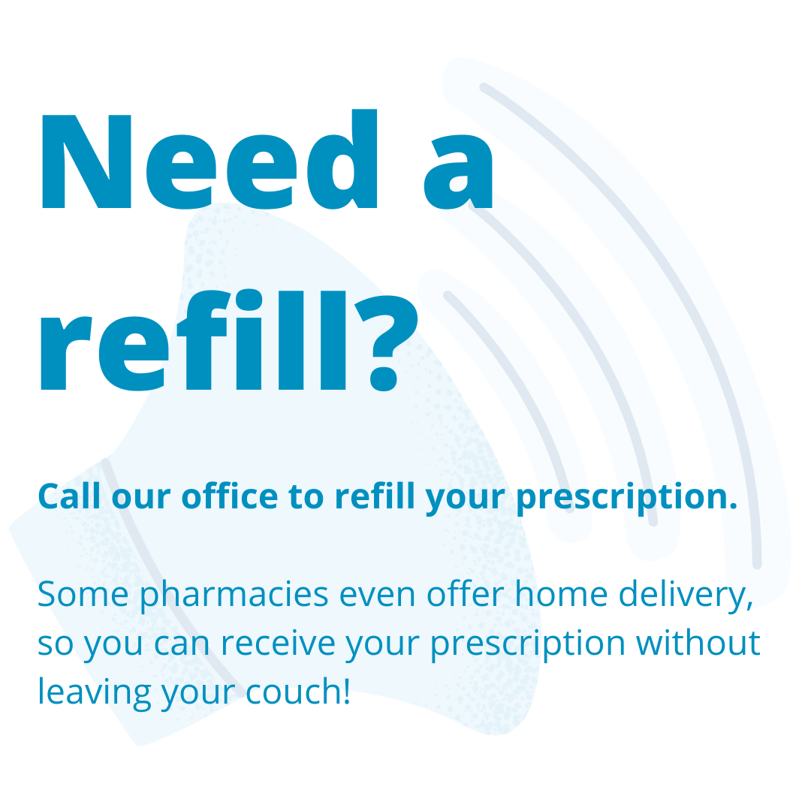

Do you need help adapting the social media images or creating your own? Please email jessica_holli@jsi.com to schedule a virtual technical assistance session and a member of our team will help you adapt or create new images to support your messaging efforts.

